BRM: Business Role Management
VIRSA 4.0 ---- > Role Expert
GRC AC 5.1, 5.2, 5.3 ----- > ERM (Enterprise Role Management)
GRC AC 10, 10.1, 12 ----- > BRM (Business Role Management)
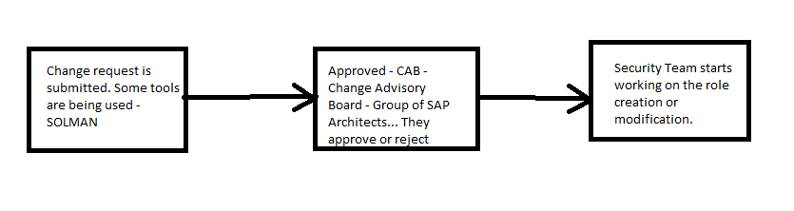
- CR - Documentation – Requirement – Tool
- Approval Process – Group of people --- Finance team Approvals FI, GRC, MM – SME or Solution Architect
- Technical Process – Security – PFCG
- Testing – UT/SIT (DEV), Integration test/UAT (QUALITY)
- Moving to PROD
SOLMAN: Solution Manager
SD – Service Desk – Ticketing Tool
ChARM – Change Access Request Management – Role Admin Process

Role Administration Concerns:
- Role Naming Convention Ex, ZS – Single, ZM – Master, ZD - Derived
- Approval
- Documentation - Who requested, who modified, who approved, T-codes (5)
- Risk Analysis
- Role should be visible to user while submitting access request - ARM

What is the purpose of BRM?
- Role Methodology in GRC – Steps - Workflow - Automating role management/administration process by Defining Workflow with Stages like – Approvals, Documentation, and Risk Analysis and make the role visible for End user (Role creation is done from GRC and then pushed into ECC) – 1 to 5 Steps are addressed.
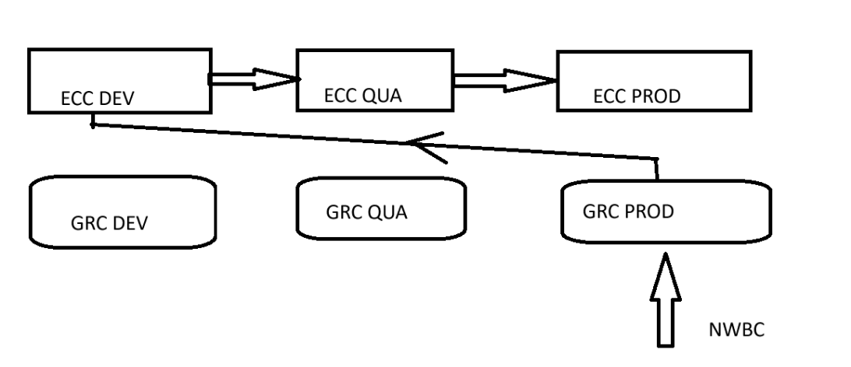
- Making the role visible (by defining attributes) for the user while filling the access form in GRC - Role Import Concept - (Role is created in the ECC Dev and moved to ECC PROD and then imported into GRC PROD NWBC) – 5th is addressed.
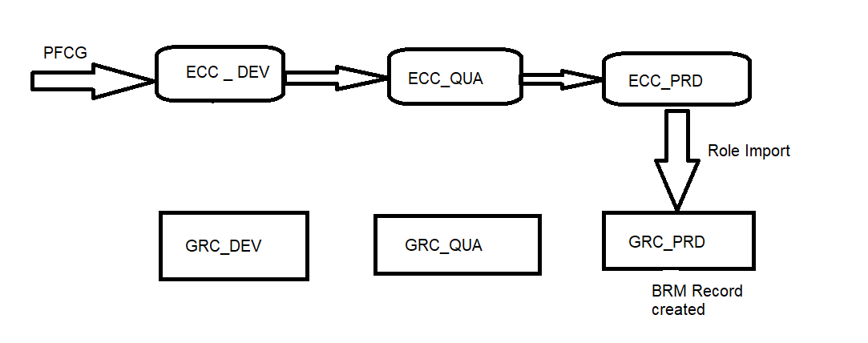

Default Role Methodology:
SPRO ----- > GRC ------- > Access Control --------> Role Management --- > Define Methodology Processes and Steps
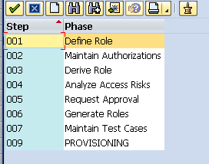

- Initiate Role Creation in GRC PROD (NWBC) ---- > Role is pushed into ECC Dev ECC QUA --- > ECC PROD

- Role Creation in GRC PROD
Role is pushed from GRC PROD into ECC Dev – Unit TEST
Role is pushed from GRC PROD into ECC Quality – Integration Test, UAT
Role is pushed from GRC PROD into ECC Prod

- Role Creation in GRC PROD ---- > Role is pushed into ECC prod Copy ---- > ECC DEV ---- > ECC QUA ---- > ECC PROD

Normal process: 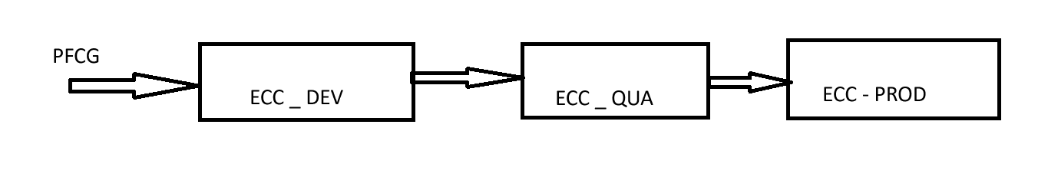
BRM process:
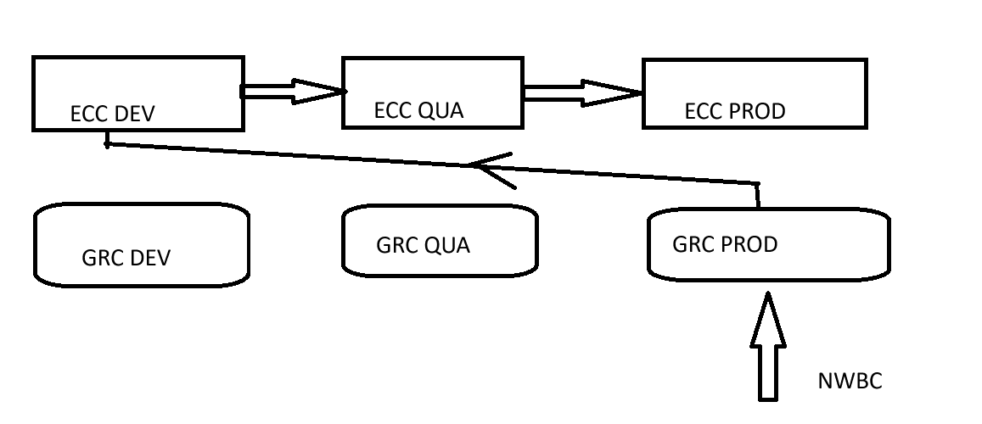
Role Types
- Business Role ----> Group of Technical Roles (Single, Comp, Group)
- Composite Role
- CUA Composite Role
- Derived Role
- Group ---- > Enterprise Portal Group
- PD Profile ------ > HR system used in Structural Auth Concept
- Profile
- Single Role
- Template ----- > Master Role

Role Naming Convention:
Single Role------ >ZS*MODULE*SUBMODULE*PROJECT_NAME
Composite Role ----- > Y*MODULE* PROJECT_NAME
Ex,,
ZS:BS:CLIENT_ADMIN:TYT
ZS:BASIS:SYSTEM_ADMIN:TYT
BASIS – BS
HR – HR
Sales and – SD
MM – MM

- Z* indicates Custom role.
- S/M/D – Indicates of role type.
- :
- Module Name
- Module Name
- :
- Sub Module
- Sub Module
- Sub Module
- Sub Module
- Sub Module
- Sub Module
- Sub Module
- Sub Module
- Sub Module
- Sub Module
- Sub Module
- :
- Project Name
- Project Name

Project Releases:
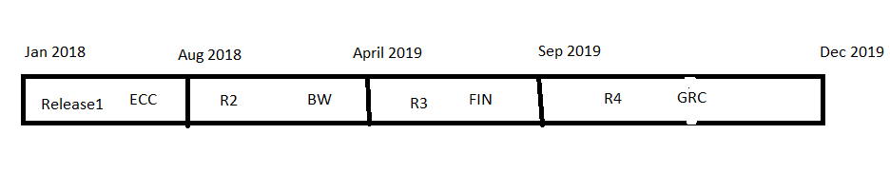
WBS - Work Break down Structure
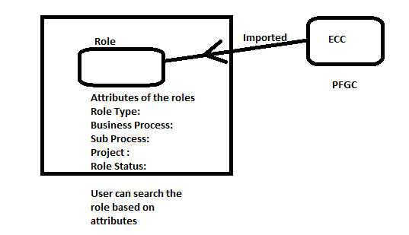
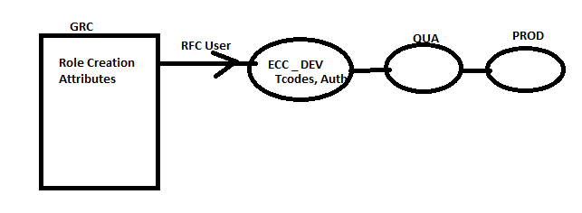
Role Creation:
Approval
Naming convention
Proper Requirement
Testing

BRF Plus:
Application where we can design rules
If “Role Type” is SIN ---- > SINGLE
If “Role Type” is COM ---- > COMP
If “Role Type” is BUS ---- > BUSINESS

Condition groups:
SINGLE ---- > CG1
COMP ----- > CG2
BUSINESS --- > CG3

Mapping Condition groups with Role Methodology:
CG1 ---- > Single role Methodology – 6 Steps
CG2 ---- > Comp Role Methodology – 4 Steps
CG3 ----- > Business Role Methodology – 3 Steps

Role Import Concept:

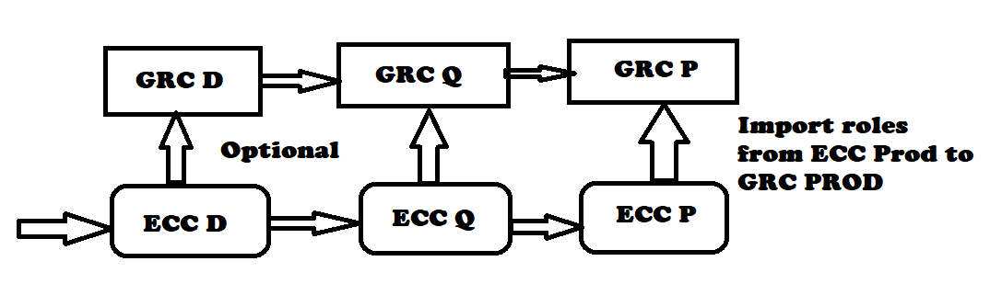

Create the role in the Backend and then import the role into GRC, define attributes (Define Role) and make it ready for assignment (Provisioning) in the GRC system.
Basic purpose of BRM is to make the role visible for user while submitting access form (ARM)
Single/Mass role Import:
NWBC ---- > Access Management ---- > Role Mass Maintenance ----- > Role Import

When the role imported/created thru BRM is not visible in ARM – while filling Access form:
      - Below entry should be YES.
How to make this entry as YES? Through SYNC job…
      - Role Status: Production
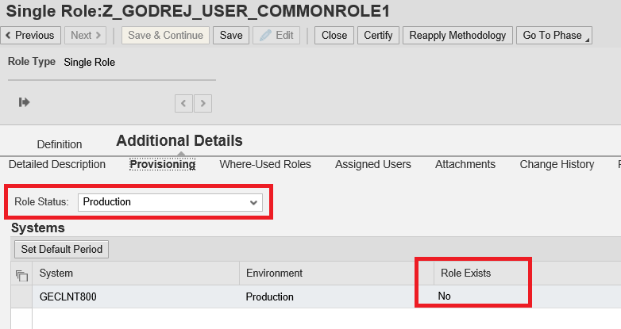
Template is needed to load the data into GRC system for multiple roles
Click here to download attribute file template
Mandatory Columns to be filled for all role types: A to H, AC, AF, AG
Derived Role – T (Master Role - additional mandatory column to be filled)
Comp Role - X (Associated Roles - additional mandatory column to be filled)
Business Role -X, Y (additional mandatory columns to be filled)
Note: Associated Roles (column X) & Master Role (Column T) – should be imported already into BRM before you import Comp role or Business Role and Derived Role.
Derived Role ---- > Master Role
Comp Role ---- > single Roles
Business Roles ----- > Single, Comp, Group

Single Role
Comp Role ---- > Single Roles
Derived Role --- > Master Role
Comp Role --- > DR1, SR1

1.Single Roles
2.Master Roles
3.Derived Roles
4.Comp Roles
5.Business Roles
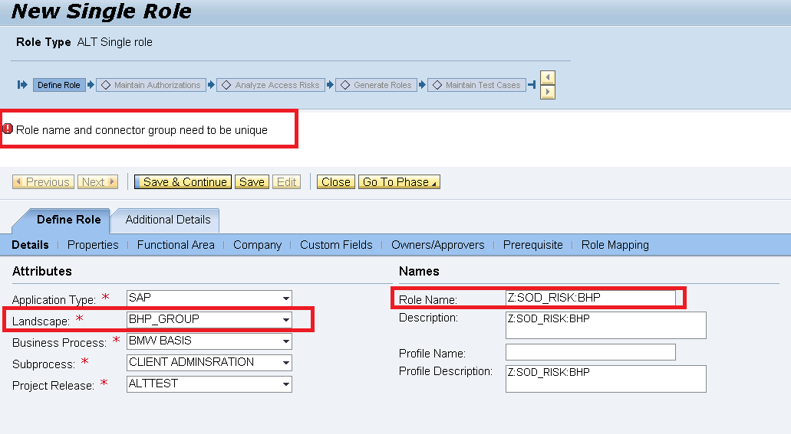

Connector Group ----- > Landscape
GE_GROUP
ECC - R1
BW – R1
CRM – R1
FIORI – R1

BMW_GROUP
ECC - R1
BW - R1
CRM - R1

ECC_GROUP
ECC

BW_GROUP
BW

FIORI_GROUP
FIORI

Role Owner:
Role owners are responsible for approving either role content or user-role assignment or both
- Create the USER ID in GRC system
- Declare him as Role Owner in Access Control Owners Table
- Define Role Owner for the respective roles
What is the difference between Assignment Approver and Role Content Approver?
Ans:
- Assignment Approver – Person who approves for assignment of role in ARM
- Role Content Approver – Person who approves for Role maintenance which includes Role creation, modification and deletion in BRM

Business Role:
- It is a collection of Technical Roles (Single/Comp/Derived/Master/Java UME Group/profile/Business Role) belonging to different PROD Systems/Landscapes
- Business Role exists only in GRC system (NWBC) (Not in PFCG)
- Composite role is collection of Single roles belonging to same system
- Business Role is collection of technical roles belonging to different systems
- In the earlier version GRC AC 5.3, this was like ROLE MAPPING concept.
- Launched in GRC 10
Ex,, Finance Accountant User needs following access

Finance Dept
S4HANA/ECC system --- >
FI AP: Accounting Officer(R1), Accounting TL(R2), Accounting Manager(R3), Analyst (R9)
Fiori System ---- > Acc off (R4) Accounting TL(R5), Accounting Manager(R6), Analyst (R10)
GRC system ---- > Acc off/Analyst (GRC req – R7) Acc Man (GRC Approver – R8)

Finance AP Accounting Officer
ECC – R1
FIORI – R4
GRC – R7

ECC – R1, R2, R5
BW – R3
FIN – R4
EP – G1
GRC – Requestor Role
Security Consultant
ECC – Sec Role
BW- Sec Role
HR – Sec Role
or
Finance Accountant
System | Role
ECC | R1, R6, R7
ECC | R2
BW | R3
FI | R4
EP | G1

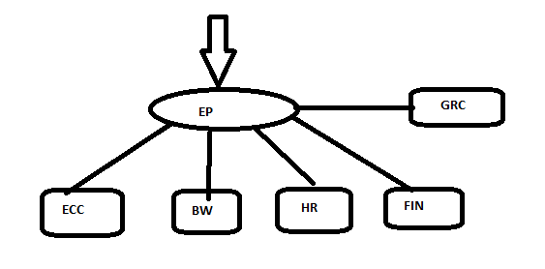
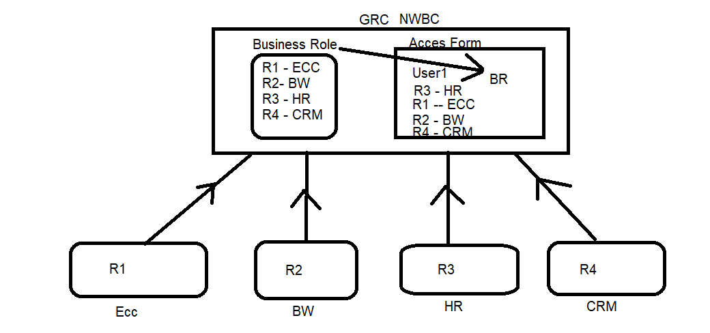
Finance Team:
Clerk – T1, T2, T3
Supervisor – T5
Accountant – T6
Manager – T1, T2, T3, T4, T5, T6
Important Tables: (GRACROLE*/GRACRL*)
GRACRLCONN ---- > Backend System Role details
GRACUSERCONN ---- > Backend User Details
GRACROLE ---- > BRM Role Records
GRACUSERROLE --- > User Role Assignments of Multiple systems connected to GRC
GRACROLERELAT ---- > Role Relationships (Comp – Single, BS- Roles)
Default Role:
Generic or Common role which must be assigned to every user. We can make this as Default role so whenever user fills the access form, this role is added to the access form automatically and assigned to user when user is created.
- Parameter Group: ACCESS REQUEST DEFAULT ROLES
Parameter 2009: Consider Default roles – YES/NO
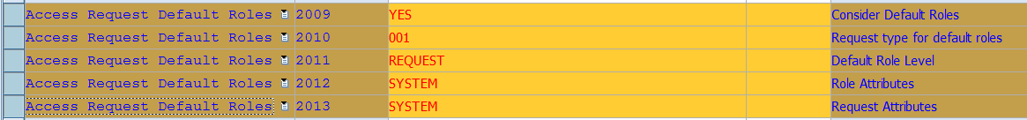
- Path: NWBC ---- > ACCESS MANAGEMENT ------ > Role Management --- > Default Roles

Role Mining:
2018 -- > Role 1 ---- > 10 T-codes ---- Assigned to several users.
2020 --- > Role 1 ---- > 10+5 = 15 T-codes
2024 -- > Role 1 ---- > 10+5+5 = 20 T-codes
2026 --- > Audit team ---- > Action usage Logs --- > 8 T-codes
T-code is Obsolete now
New t-code has been Launched Ex, ST01--- > STAUTHTRACE, SE16 --- SE16N
Remove the t-codes from Role.

Roles Reaffirmation/Role Certification:

